**Supplementary Materials Documentation**

**Summary of bootstrapping the 'stepAIC()' procedure for Original Linear Regression Model**

Bootstrap samples: 100

Direction: backward

Penalty: 2 * df

*Initial Model:* pH ~ feed1 + feed2 + feed3 + feed4 + feed5 + feed6 + feed7 + Temp1 + Temp2 + Temp3 + Temp4 + Temp5 + Temp6 + Temp7 + pH1 + pH2 + pH3 + pH4 + pH5 + pH6 + pH7 + DO1 + DO2 + DO3 + DO4 + DO5 + DO6 + DO7

*Final Model:*

pH ~ feed1 + feed3 + feed7 + Temp1 + pH1 + pH2 + DO2 + DO3

**Supplementary Table 1**. Regression Coefficients

|  |  |  |  |  |  |  |  |  |  |
| --- | --- | --- | --- | --- | --- | --- | --- | --- | --- |
| **Variable** | Intercept | feed1 | feed3 | feed7 | Temp1 | pH1 | pH2 | DO2 | DO3 |
| **Coefficient** | 1.414 | -0.068 | 0.046 | -0.035 | -0.003 | 0.605 | 0.259 | -0.037 | 0.021 |

**Summary of Bayesian linear regression**

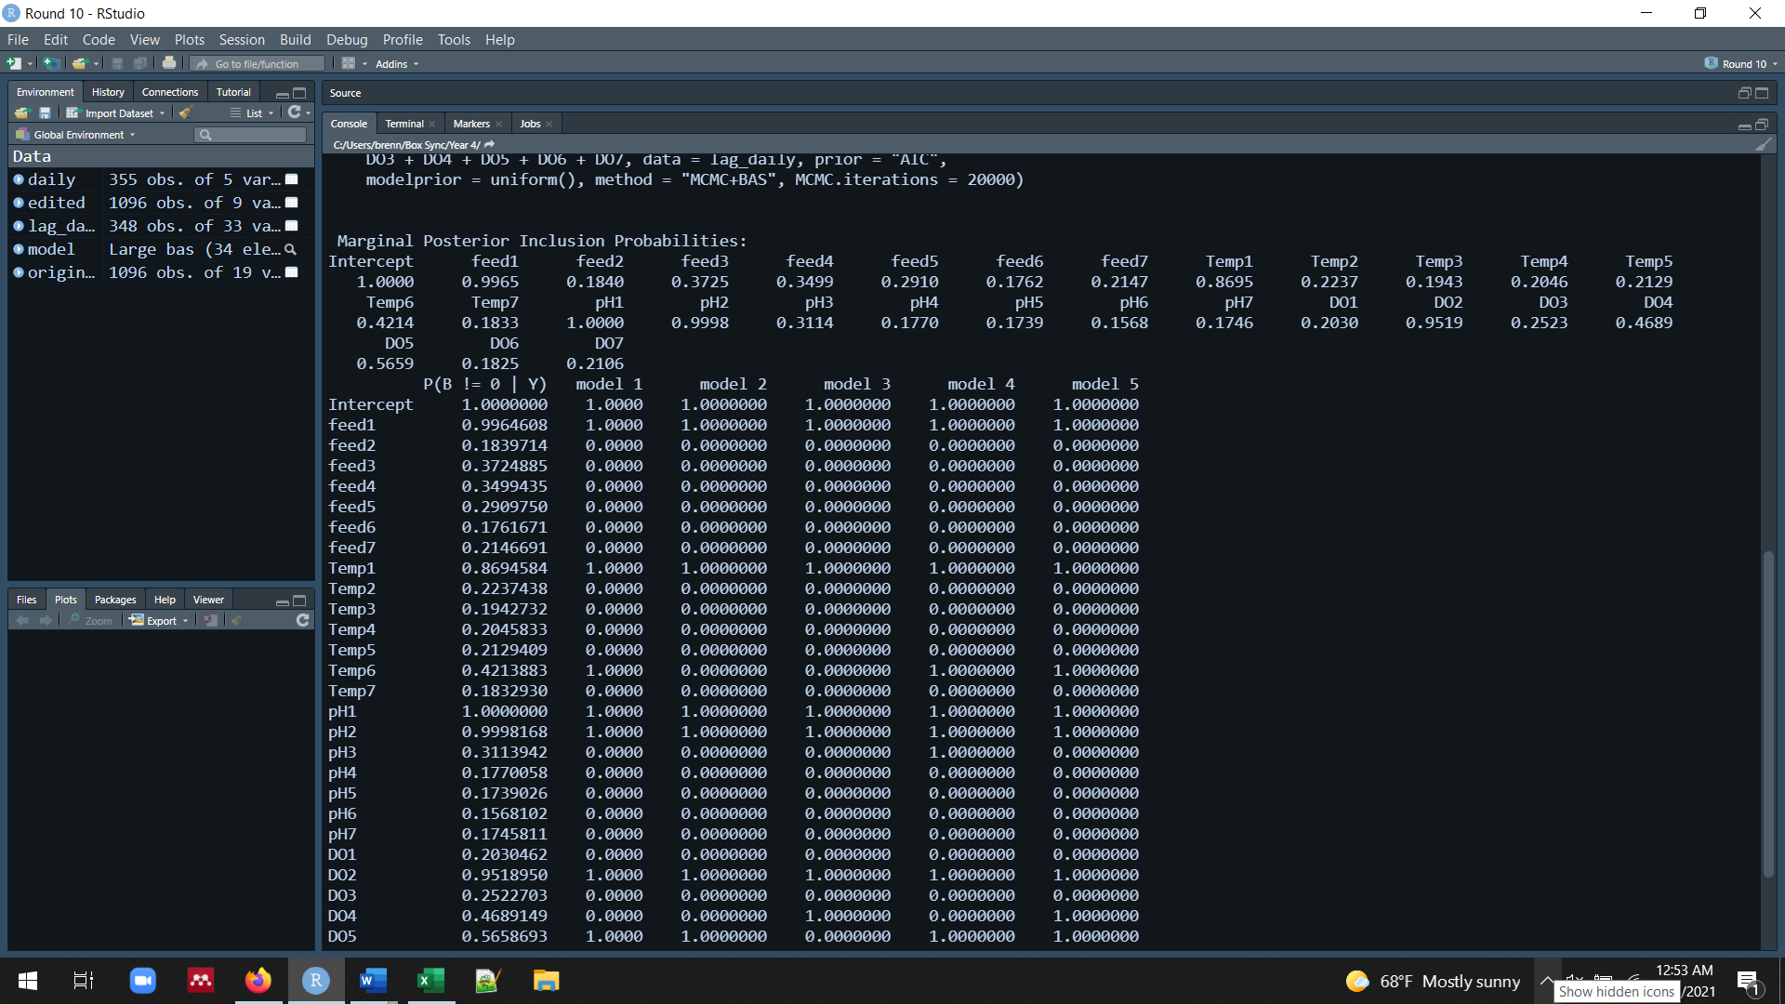bas.lm(formula = pH ~ feed1 + feed2 + feed3 + feed4 + feed5 + feed6 + feed7 + Temp1 + Temp2 + Temp3 + Temp4 + Temp5 + Temp6 + Temp7 + pH1 + pH2 + pH3 + pH4 + pH5 + pH6 + pH7 + DO1 + DO2 + DO3 + DO4 + DO5 + DO6 + DO7, data = lag_daily, prior = "AIC", modelprior = uniform(), method = "MCMC+BAS", MCMC.iterations = 20000)

